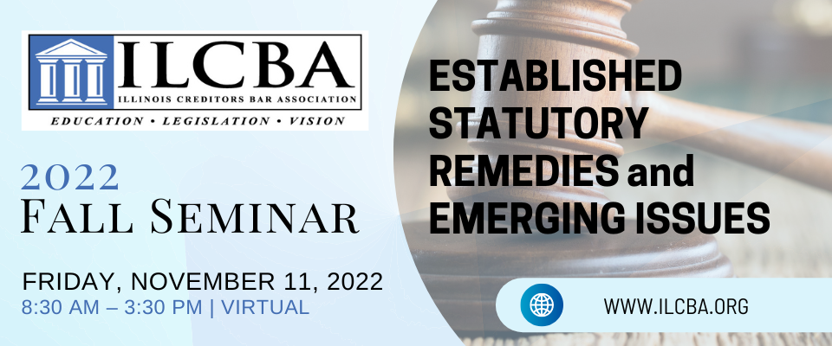
Sponsorship Opportunities - Click here to register.
Gold Sponsorship Package - $1,000
- Virtual Swag Bag*
- Listing in the vendor section of website
- 1 full page ad in online fall 2022 Seminar Program book
- 1 full page ad in online newsletter
- Linked logo on website seminar page (sponsorship level indicated)
- Social media shoutout (sponsorship level indicated)
- Banner ad on ILCBA website for 6 months
- Live or pre-recorded presentation to seminar attendees up to 5 minutes
Silver Sponsorship Package - $750
- Virtual Swag Bag*
- Listing in the vendor section of website
- 1 half page ad in online fall 2022 Seminar Program book
- 1 half page ad in online newsletter
- Linked logo on website seminar page (sponsorship level indicated)
- Social media shoutout (sponsorship level indicated)
- Banner ad on ILCBA website for 3 months
- Live or pre-recorded presentation to seminar attendees up to 3 minutes
Bronze Sponsorship Package - $500
- Virtual Swag Bag*
- 1 quarter page ad in online fall 2022 Seminar Program book
- 1 quarter page ad in online newsletter
- Linked logo on website seminar page (sponsorship level indicated)
- Social media shoutout (sponsorship level indicated)
- Live or pre-recorded presentation to seminar attendees up to 1 minutes
*Virtual Swag Bag - Vendor can offer swag bag to attendees via chat and/or email.
Attendees can follow a link provided by vendor to enter information to receive either a promo code for discounted services or even send swag by mail...contents of swag bag are up to the vendor!

